


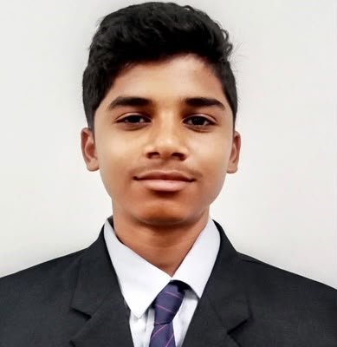

Education
Diploma in Computer science & Engineering
Hindustan Electronics Academy,

SSLC (10th)
St Anne’s High School,
State Board,
2024

Skills

- Coding
- SQL
- Debugging
- Microsoft Office
- Spreadsheets

+91 8660479814
likithn0920@gmail.com

www.linkedin.com/in/anjan-kumar-v-20ab40437

Contact

LIKITH YOGESH

CAREER OBJECTIVE

To begin my career in a reputed organization where I can apply my skills and knowledge gained during my diploma and grow professionally.

TECHNICAL SKILLS
- Basic knowledge of Software Tools
- Knowledge of Computer Network, Computer Hardware & Maintenance Application
- MS Office Word, Excel, PowerPoint
- HTML

CERTIFICATIONS
- MySql
- CyberSecurity

EXTRA-CURRICULAR ACTIVITIES

PERSONAL PROFILE
- Father Name: Yogesh Rao M.K
- Date of Birth: 16th of January 2008
- Gender: Male
- Language known: English, Kannada, Hindi, Telugu
- Nationality: Indian
- Hobbies: Dancing, Drawing, Writing
DECLARATION
I hereby declare that the above-mentioned information is true and correct to the
best of my knowledge and belief.
Date: 09/09/2026 Signature
Place: Bangalore Likith Yogesh

